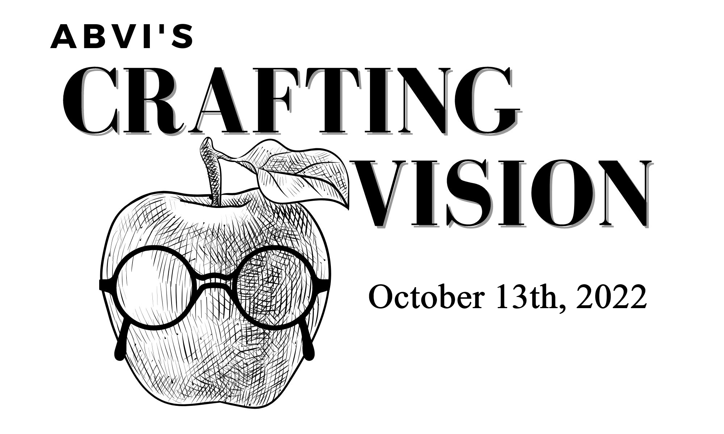

When someone is diagnosed with a condition that will result in a loss of sight or blindness, their responses are not only emotional in nature – anger, frustration, fear, and loss – but also include real questions about how to maintain an independent life.

Now in our 109th year, the Association for the Blind and Visually Impaired (ABVI) provides vision rehabilitation services to people of all ages with severe vision loss, teaching them how to remain active and self-sufficient.

Here is some “in-cider” information…. **Crafting Vision 2022 is coming!** This year, our event takes place on Thursday evening, October 13th, from 6:00 to 9:00 p.m. at Vander Mill Tap Room and Restaurant, 505 Ball NE, Grand Rapids, 49503. This casual, interactive experience will include hearty appetizers, beverages (featuring cider, of course), as well as the opportunity to learn more about ABVI… and some surprises! Sound “app-eel-ing?”

Your support will help a visually impaired employee learn how to use adaptive equipment to succeed at work…or train a parent to cook again for their family when they never thought they would…or the student learn how to use the white cane to be independent and to utilize public transportation…and so much more!

We are delighted to invite you to become a sponsor for Crafting Vision 2022. Attached are sponsorship levels and forms. Simply fill out the form and return it to ABVI by October 3rd, and you will be the “apple of our eye!” For questions, please contact Brad Kaufmann at 616-840-8898 or [Brad.Kaufmann@maryfreebed.com](mailto:Brad.Kaufmann@maryfreebed.com).

Thank you in advance for your consideration and support. Looking forward to seeing you in October.

Sincerely,

The Crafting Vision 2022 Event Committee



CIDER MILL SPONSOR | $8,000

* Ten tickets for guests to attend the event and 2 drink tickets for each guest
* Sponsor’s logo prominently displayed on all event materials
* Sponsor’s logo prominently displayed on invitation
* Recognition on organizational and event social media sites
* Recognition from the podium during event

HARVEST SPONSOR | $5,000

* Eight tickets for guests to attend the event and 2 drink tickets for each guest
* Sponsor’s logo prominently displayed on all event materials
* Recognition on organizational and event social media sites
* Recognition from the podium during event

ORCHARD SPONSOR | $2,500

* Six tickets for guests to attend the event and 2 drink tickets for each guest
* Sponsor listed on printed event materials
* Recognition from the podium during event

APPLE BLOSSOM SPONSOR | $1,500

* Four tickets for guests to attend the event and 2 drink tickets for each guest
* Sponsor listed on printed event materials

INDIVIDUAL TICKETS | $60 each – includes 2 drink tickets

Individual tickets to the event will be available through ABVI and our website [www.abvimichigan.org](http://www.abvimichigan.org)

beginning August 15, 2022.



**SPONSORSHIP COMMITMENT**

SPONSOR INFORMATION

Contact Name: _________________________________________________________________

Company Name: _______________________________________________________________

Street Address: ________________________________________________________________

City, State, Zip: ________________________________________________________________

Phone: _______________________Email: __________________________________________

SPONSORSHIP LEVEL

🞏 Cider Mill Sponsor | $8,000

🞏 Harvest Sponsor | $5,000

🞏 Orchard Sponsor | $2,500

🞏 Blossom Sponsor | $1,500

PAYMENT DETAILS

🞏 I have enclosed a check (payable to the Association for the Blind & Visually Impaired)

🞏 Please Invoice me

🞏 Please charge my credit card

□ MasterCard □ VISA □ AmEx □ Discover Card

Credit Card Number: ________________________________________Expiration Date: __________

Signature: _________________________________________________ Security Code: ___________

**For full sponsorship benefits, please return form by September 15 to**

Macintosh HD:Users:Jamie:Desktop:ABVI-LogoOL.eps

456 Cherry Street SE | Grand Rapids, MI | 49503

For additional questions, please contact

Brad Kaufmann at 616.840.8898

or Brad.Kaufmann@maryfreebed.com.

**EVENT TICKET REGISTRATION**

**Sponsor Name:**

GUEST ONE NAME ___________________________________________________________________

Email: ______________________________________________________________________________________

GUEST TWO NAME ___________________________________________________________________

Email: ______________________________________________________________________________________

GUEST THREE NAME _________________________________________________________________

Email: ______________________________________________________________________________________

GUEST FOUR NAME __________________________________________________________________

Email: ______________________________________________________________________________________

GUEST FIVE NAME ___________________________________________________________________

Email: ______________________________________________________________________________________

GUEST SIX NAME _____________________________________________________________________

Email: ______________________________________________________________________________________

GUEST SEVEN NAME _________________________________________________________________

Email: ______________________________________________________________________________________

GUEST EIGHT NAME _________________________________________________________________

Email: ______________________________________________________________________________________

Please submit names by October 10th to guarantee your guest’s name tag will be ready.

Send to [Brad.Kaufmann@maryfreebed.com](mailto:Brad.Kaufmann@maryfreebed.com)